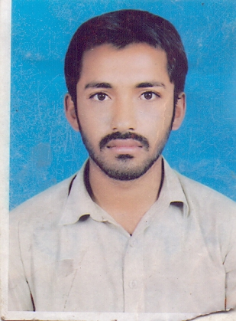
M.SYAM KHAN
N Block Pakpattan Road
Tehsil Arifwala Distt. Pakpattan
Cell No. 0305-7737331

OBJECTIVE:

To join a dynamic and progressive organization offering sample opportunities for diversified experience, and seeking a position which will allow for continued professional growth, offering an environment in which advancement is based on strength of individual contributions to the realization of organizational goals.

PERSONAL INFORMATION:

Father’s Name: Muhammad Iftakhar
Date of Birth: 19/03/1993
Nationality: Pakistan
N.I.C #: 36401-6826194-1
Marital Status: Single
Religion: Islam

QUALIFICATIONS:
Primary Pass

Experience

- 7 years’ Experience in CAR POSHISH

language

- Urdu, Punjabi

REFERENCE:

- Reference will be furnished on demand
- Hard work & Honesty is my first Reference.
- www.learningall.com

