Maximum Marks: 100 Maximum Time: 3 hours

Check List:
Paper contains 23 pages including this page and no page is torn or missing
Part I consists of 20 multiple choice questions and the first portion of the relevant section Part II contain 50 multiple choice and one or more descriptive questions
Answer Booklet for Part II

- Part I has 5 multiple-choice questions from each of the four disciplines of the competition and all the candidates are expected to attempt this part. It carries 20 marks. The multiple-choice portion of the relevant section of Part II carries 50 Marks. Correct answer will carry +1 mark; 1/3 mark will be deducted for each incorrect answer.
- To answer Part I, and the multiple-choice portion of the relevant section of Part II detach the pages entitled ‘Answer Sheet for Part I and Answer sheet for Part II’. Write your name on the space provided in these sheets. There are four choices (a, b, c, d) corresponding to each multiple-choice question. Color one of these choices as shown in the example, which in your opinion is correct. If you want to change the answer, you may do so after crossing out the previous answer. Rough work may be done in the Answer Booklet for Part II by clearly specifying ‘Rough Work’.
- The descriptive question(s) of Part II should be solved in the Answer Booklet for Part II. This (these) question carries 30 Marks.
- The last page will provide you the opportunity to give frank opinion about the test and is meant to motivate you to carefully read the question paper before attempting it. It will be used to discriminate between candidates having similar scores. Students will be short-listed for a one-week Training Camp in July, August or September on the basis of their performance in this screening test. Please make sure that we have your phone/fax number and/or e-mail address on which you can be informed about the result in about one month.
- Recommended time for Part I is 30-40 minutes and for the multiple-choice portion of Part II and its descriptive portion is about one hour each. The rest of time is for reading and commenting.
- No leaf from the question paper or Answer Booklet is to be torn out and these must be handed over to the examiner, even if no question has been attempted. Any one found using unfair means would be disqualified.
- You may use scientific calculators.
- No questions will be entertained and no clarification will be made during the test. In case of doubt, please write down your remarks along with your comments.
- You must attempt Part I and only one of the relevant portions of Part II, because to qualify screening test one should pass both Part I and the portion of Part II that is relevant to the discipline in which you wish to compete.
- The term ‘estimate’ if used in the descriptive portion of Part II means that only an approximate answer is expected from the students. Similarly the term ‘sketch’ in this Part means drawing a rough graph, which looks like what you might expect from more careful considerations.
- Please put your pen down as soon as you hear stop writing.

Part I: Multiple Choice Questions
(This part is compulsory for all Candidates)
A. Biology
1. The scientist most closely associated with the Theory of Evolution is
  - Dalton, b) Einstein, c) Mendeleyev, d) Darwin
2. All of the following are mammals except
a) Whale, b) shark, c) dolphin, d) seal
3. Zainab is expecting her 10th child. All of her other children are females. The probability that her 10th child will also be a girl is
a) 0.9, b) 0.1, c) 0.5, d) none of these
4. In an area populated by the following species which of the following would most probably have the largest population?
  - Foxes, b) rabbits, c) grass hoppers, d) field mice

5. A cell wall is present only in
a) Bacteria, b) Protozoa, c) Algae, d) Virus

B. Chemistry

- The apparatus that is most suitable for accurately measuring 230 cm³ of liquid is
  - Burette, b) Pipette, c) Cylinder, d) Beaker

- The substance that conducts electricity by the movement of ions is
  - Graphite, b) Mercury, c) molten Sodium Chloride, d) molten Lead

- The gas that is industrially obtained using fractional distillation is
  - Nitrogen, b) Chlorine, c) Ammonia, d) Hydrogen

- Oxidation takes places on the following electrode
  - Anode, b) cathode, c) both anode and cathode, d) none of these

- The most effective means of corrosion is
a) Air b) water c) CO_{2,} d) N₂

C. Mathematics

1. If n is a number such that , then n is equal to
a) 0 b) 1 c) 2 d) infinitely many

2. If x= 2- √3, then x + 1/x equals

- 4, b) 2 + √3, c) 4 - √3 , d) 1/(2 + √3)

3. The age of father is 40 years. 5 years earlier his age was seven times his son’s age. The present age of his son is
a) 10 b) 5 c) 7 d) 12

4. The length of a rectangle is twice its width. If its perimeter is 60 m, then its area is
- 600 m², b) 400 m² , c)150 m², d) 200 m²

5. The base of a triangle is twice its hypotenuse, the sine of the angle opposite to its base is
- √3/2, b) 1, c) 1/2, d) √3

D. Physics
- Which of the following situations is impossible
    - A body having velocity East and acceleration West, (b) a body having velocity East and acceleration East,
(c) a body having zero velocity but non-zero acceleration, (d) a body having constant velocity but non-zero acceleration

2. If a fixed mass of water is cooled slowly from 10⁰C to 0⁰C, its volume
a) Increases steadily, b) decreases steadily, c) first increases and then decreases d) first decreases and then increases

- A block slides down a frictionless ramp and a sphere rolls without sliding down a ramp of the same angle ө. The block and sphere have the same mass, start from rest at point A, and descend through point B In that descent. The work done by the gravitational force on the block is
a) Greater than, b) less than, c) the same as the work done by the gravitational force on the sphere. d) Need more information to answer this question
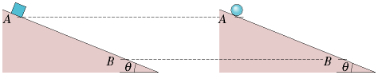

4. Which of the following properties of a solid would change if it were transported from the Earth to the Moon?
a) Mass, b) volume, c) density, d) weight
- A moth at about eye level is 10 cm in front of a plane mirror; you are behind the moth, 30 cm from the mirror. The distance between your eyes and the apparent position of the moth's image in the mirror is
a) 50 cm, b) 30 cm c) 40 cm, d) 60 cm

Part II (In this part, candidates are required to attempt only the one subject, for which they are competing.)

Biology- Multiple Choice Questions

- When two glucose (C₆H₁₂O₆) molecules are combined to form a molecule of maltose (C₁₂H₂₂O₁₁), the formula of the maltose molecule is not C₁₂H₂₄O₁₂ because
- Hydrolysis takes place
- Dehydration synthesis takes place
- Transpiration takes place
- Water is added

- Of the following terms, the one that includes all others is

Oxidation

Respiration

Metabolism

Polination

Auxin serve to increase rate of

Digestion

Circulation

Reproduction

Growth

- Of the following terms, which one includes all the others

Species

Class

Phylum

Order

Ciliated epithelial cells in nasal passages are useful because they

Keep out dust and bacteria

Provide sense of smell

Reduce the breathing rate when the air is impure

Reduce the humidity in inhaled air

- An independent organism is discovered that does not contain a nucleus. In all liklihood, it would be classified in the kingdom

Monera

Protista

Fungi

Animal

- Why do legume plants enrich soil?

They remove selenium a deadly poision

They encourage breeding of earthworms

Their roots contain nitrogen-fixing bacteria

Their root system penetrate 2 meter below the surface

- Messanger RNA is important in protein synthesis because it

Contains the 20 essential amino acids

Carries code from DNA to nucleus

Carries the code from DNA to the ribosomes

Is transmitted to the nucleotide

- In which of the following life processes is ATP produced?
I Photosynthesis
II Aerobic respiration
III Anaerobic respiration

I only

II only

I and II only

I, II and III

- In ecological succession, since lichens grow on bare rock, they are considered to be

Primary consumers

Pioneer organisms

Climax organisms

Producers

- A green plant cell contain all of the following structure except

DNA

Genes

A cell wall

A centriole

- The innermost chamber of respiratory system into which air can be drawn is the

Bronchiole

Bronchus

Air sac

Bronchiole tube

- In aerobic respiration, the final hydrogen acceptor is

Molecular oxygen

Carbon dioxide

Water

ATP

- Antibodies are chemicals that are

Non-specific

Produced by the body in response to antigen

Synthesized from glycogen

Transported by red blood cells

- Carbohydrates are organic compounds containing C, H, O in which the hydrogen and oxygen occur in the same ratio as in water. Of the following compounds, the carbohydrate is:

Stearin (C57H110O6)

Thiamin (C12H18N4O2S)

Palmatin (C51H98O6)

Cellulose (C₆H₁₀O₅)n

- The best description of an enzyme is that it

Becomes hydrolyzed during chemical reactions

Becomes dehydrated during chemical synthesis

Speeds up the rate of chemical reactions

Serves as an inorganic catalyst

- In what way do valves in the vein aid in circulation?

They prevent the spurting action from becoming too uneven

They separate oxygenated from deoxygenated blood

They filter out blood clots

They keep the blood from flowing backwards

- A person with insufficient iron in his diet may become anemic because

The spleen removes too many leucocytes from the blood

The clotting reaction time is reduced

Iron is needed in making fibrinogen

Iron is used in making hemoglobin

- In which of the following parts of a cell is RNA found?

I Nucleus
II Cytoplasm
III Ribosome

I only

II only

I and III only

I, II and III

- One similarity of DNA and RNA is that they both contain

Nucleotide

ATP

Thymine

Deoxyribose sugar

- One of the characteristics of all living things is that they

Require oxygen for respiration

Originate from preexisting life

Carry on heterotrophic nutrition

Carry on autotrophic nutrition

- From what part of plant does a seed develop?

Hilum

Anther

Oviduct

Ovule

- Red corpuscles are to hemoglobin as chloroplasts are to

Guard cells

Palisade cells

Chlorophyll

Photosynthesis

- Genetic information is transmitted from DNA to

Amino acids

Chromosomes

Proteins

The site of protein synthesis

- By which of the following can movement of materials across animal cell membranes be accomplished?

I Active transport
II Diffusion
III Pinocytosis

I only

II only

I and II only

All of the above

- The structure that includes all others is

Ovary

Ovule

Style

Pistil
- The position of a particular gene on a chromosome is called

Allele

Locus

Homologue

Chiasmata

- The individual who has inherited two dominant alleles for a trait is

Homozygous dominant

Homozygous recessive

Heterozygous

None of the above

- The term phenotype refers to traits like

Structure

Physiology

Behavior

All of above

- The nucleus contains

Mitochondria

Cytosol

Enzyme

DNA

- Another name for Golgi complex is

Dictyosome

Endoplasmic reticulum

Cytomembrane system

None of the above

- Leucoplasts are a kind of

Lysosomes

Chloroplsts

Plastids

Grannum

- Vacuole in plants are responsible for

Photosynthesis

Cellular excretion

Turgor pressure

Starch storage

- Hydrogen peroxide degradation in a cell is a function of

Lysosomes

ribosomes

Mitochondria

Microbodies

- Controlled degradation and material processing is a function of

Lysosomes

Amyloplast

Cytoskeleton

Nucleoid

- Cell membranes are composed of

Lipids and proteins

Phospholipids

Proteins and carbohydrates

Lipids and terpenoids

- Shrinkage of cytoplasm away from the cell walls is

Explasmosis

Imbibation

Osmosis

Plasmolysis

- Stomata open when they are

Flaccid

Turgid

Dormant

Dividing

A waxy cuticle

Retards water loss

Speeds water loss

Helps in respiration

Attracts pollens

- A seven celled structure with 8 nuclei is

Stamen

Ovary

Embryo sac

Seed

- Nectar

Provides nourishment to the plants

Kills germs

Attracts pollinators

Is sweet

- Cytokinins are examples of

Auxins

Enzymes

Hormones

Seeds

- Pollen grain develops from haploid microspores then later develop into sperm bearing

Gametophyte

Sporophyte

Megaspore

Pollen sac

- Double fertilization is characteristic of

Fungi

Flowering plant

Roses

Algae

- Triploid endosperms nucleus is a result of

Mitosis

Cross pollination

Self pollination

Double fertilization

- Mutually beneficial association is called

Symbiosis

Saprophytism

Parasitism

Commensalism

- Root nodules harbor

Saprophytic fungi

Parasitic bacteria

Nitrogen fixing bacteria

Viruses

- Bacteriophages are

Parasitic bacteria

Spore forming bacteria

Virus attacking bacterai

None of the above

Bacteriophage exhibit life cycle that are

Lytic

Lysogenic

Neither A or B

Both A & B

- Cytosine and guanine are

Purines

Pyrimidines
c) Glycols
d) Glycerol

Biology: Descriptive Question(s)

Describe the key features of Virus and Bacteria and list a few diseases caused by them?

Chemistry- Multiple Choice Questions

- When 7 grams of phosphoric acid (Mol. Wt 98) is dissolved in 500 grams of water, the resulting solution is

a) 0.16 molar b) 0.14 molar c) 0.14 normal d) 0.28 normal
2. Which of the following is the best conductor of electricity?
a) water b) NaCl solution c) solid NaCl d) sugar solution

3. Which of the following is not normally considered to be an oxidizing agent?
a) NaOH b) H₂O₂ c) Oxygen d) Chlorine

- The regent used for testing a carbonate radical is

a) H₂S b) NaCl c) HCl d) CaCl₂

- In the reaction
Some of the nitrogen atoms

a) Gain 3 electrons b) Gain 1 electron c) Lose 3 electrons d) Lose 1 electrons

- Chlorous acid has the formula

a) HCl b) HClO c) HClO₂ d) HClO₃

- What is the atomic volume of lead? Given at wt = 207.2 and density = 11.4 g/cc
a) 4.5 b) 9.1 c) 18.2 d) 27.3

- Which one of the following acids find common use at home?

a) HNO₃ b) H₂SO₄ c) H₄C₂O₂ d) H₂C O₃

- Which one of the following oxide will be acidic in character?

a) Na₂O b) BaO c) P₂O₅ d) K₂O
- Given 2HI H₂ +I₂ ΔH=+10kJ
The concentration of iodine in the equilibrium mixture can be increased by
a) raising the temperature b) raising the pressure
c) Lowing the pressure d) adding a catalyst
- The gas produced when copper reacts with concentrated nitric acid is
a) Oxygen b) dinitrogen oxide c) nitrogen dioxide d) nitrogen oxide
- Nitric acid is a
a) Week acid and week oxidizing agent
b) Strong acid and week reducing agent
c) Strong acid and strong reducing agent
d) Week acid and strong oxidizing agent

- Which of the following does not decompose on heating
a) NaCl c) PbSO₄ c) KNO₃ d) AgNO₃
- In the sun hydrogen is converted into
a) Uranium b) helium c) barium d) plutonium

- How many grams of sulfur are present in 1 mole of H₂SO₄
a) 2 b) 98 c) 64 d) 32

If K_{e} is small, it indicates the equilibrium occurs
A) At a low product concentration
B) At a high product concentration
C) After a considerable time
D With no forward reaction

In which period is the most electronegative element found
A) 1 B) 2 C) 3 D) 4

The first and simplest alkane is
A) Ethane B) methane C) C₂H₂ D) methene

Slight oxidation of a primary alcohol gives
A) a ketone B) an organic acid C) an ether D) an aldehyde

The characteristic functional group of organic ester is
A) –CHO B)-CO- C)-COOH D)-COO-

Fermentation of glucose gives
A) CO₂ and H₂O B) CO and alcohol C) CO₂ and CH₃OH D) CO and C₂H₅OH

The organic acid that can be made from ethanol is
A) formic acid B) acetic acid C) glutaric acid D) butanoic acid

An ester can be prepared by the reaction of
A) two alcohols B) two acids C) an alcohol and aldehyde D) an alcohol and organic acid

Phenol is a derivative of
A) alkene B) aliphatic hydrocarbon C) aromatic hydrocarbon D) alkyne

Sucrose is a
A) reducing agent B) monosaccharide C) disaccharide D) sugar with an aldehyde

Compounds that have the same composition but different structural formula are called
A) polymers B) isomers C) copolymers D) isotopes

Fehling’s solution gives a positive test with
A) glucose B) sucrose C) copper(I)oxide D) starch

What is the structure associated with the sp² hybrid
A) triangle B) tetrahedron C) octahedron D) square planer

31) The bonding that explains the variation of the boiling point of water from the boiling points of similar structured molecules is
A) hydrogen bonding B) van der Waals forces C) ionic bonding D) coordinate covalent bonding
- Which formulae could represent the empirical formula and the molecular formula of a given compound
A) CH₂O and C₄H₆O₄ B) CHO and C₄H₁₂O₆ C) CH₄ and C₅ H₁₂ D) CH₂ and C₃H₆

A binary compound of sodium is
A) sodium chromate B) sodium chloride C) sodium hypochlorite
D) sodium perchlorate

How many molecules are there in 2 moles of water ?
A) 36 B) 6.023 x 10 ²³ C) 2/18 D) none of these
- The addition of a catalyst to a reaction
A) changes the enthalpy B) changes the entropy C) changes the nature of product
D) changes the activation energy
- The extent of ionization depends upon the
A) nature of the solvent B) nature of the solute C) temperature of the solution D) all of the above
- At the beginning , the reaction rate for the reactions is
A) largest then decreasing B) largest and then remains constant C) smallest then increasing
D) smallest and remains constant
- What is the oxidation number of Mn in KMnO₄
A) +2 B) +4 C) -1 D) +7
- Enthalpy is an expression for
A) heat content B) energy state C) reaction rate D) activation energy

- The emission of a beta particle results in a new element with atomic number
A) increased by 1 B) increased by 2 C) decreased by 1 D) decreased by 2
- A metallic oxide placed in water would most likely yield an
- acid B) base C)metallic anhydride D)basic anhydride
- A 10 % solution of NaCl means that in 100 grams of solution there is
A) 5.85 g NaCl B) 58.5 g NaCl, C) 23 g NaCl , D) 10 g of NaCl

46. Commercial hydrogen is frequently obtained from which one of the following?

a) Water gas (b) Coal gas (c) Producer gas (d) Marsh gas

47. How many isotopes of hydrogen are known?

a) 2 (b) 3 (c) 4 d) 5

    - What is the oxidation number of S in H₂SO_{4?}

a) 2 (b) 4 (c) 6 (d) 8

    - Which of the following substance when added in H₂O will cause the bulb to light?
a) Sugar (b) Ethanol (c) Lead (d) Na

50 Which of the following elements requires the two electrons for one mole of atoms to be liberated during electrolysis?
a) Al (b) Ca (c) C (d) Na

Chemistry - Descriptive Question
How would you distinguish between aliphatic and aromatic hydrocarbon

Mathematics- Multiple Choice Questions

1. If the radii of the circles in Figure 1 are 5 and 3, the centers are A and B and both ∠FAG and ∠DBC are right angles, what is the perimeter of ΔCEG?  - 32  - 38.63  - 30  - Cannot be determined |  |  |  |  |  | 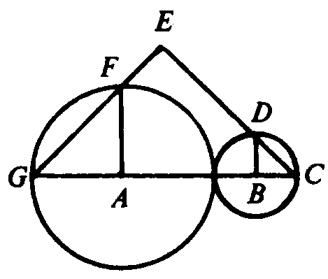  Figure 1
2. In Figure 2, if AD = 2 and DB = 3, then the ratio  $\frac{\text{area}Δ\text{ADC}}{\text{area}Δ\text{ABC}}$ is  a) $\frac{2}{3}$ b) c) d) |  |  |  |  |  | 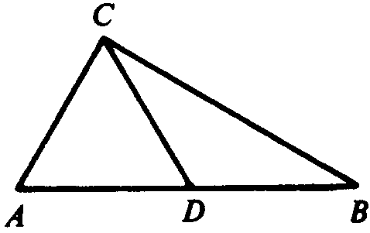  Figure 2
3. If k+ 1 represents a given odd integer, which of the following must also be an odd integer?
a) k( k+1) b) (k+1)(k+2) c) (k+1)(k−1) d) (k+1)²−1

4. In Figure 3, arc CD is a semicircle. AB ⊥ CD, BC = 3, BD = 4. Then the length of AB =  a) 3.25 b) 4.56 c) 3.46 d) 7.00 |  |  |  |  |  | 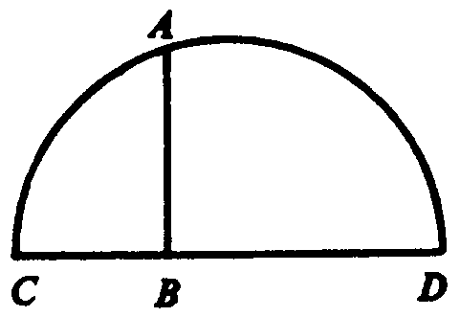  Figure 3
5. |  | For a real number x, √√-x is equal  a) +x b) -x c) complex d) pure imaginary
6. |  | What is the relationship between the areas of ΔABC and ΔDBC in Figure 4?  - Equal  - Area of ΔABC = Area of ΔDBC  - Area of ΔABC > Area of ΔBDC  - Area of ΔABC + 1 = Area of ΔBDC |  |  | 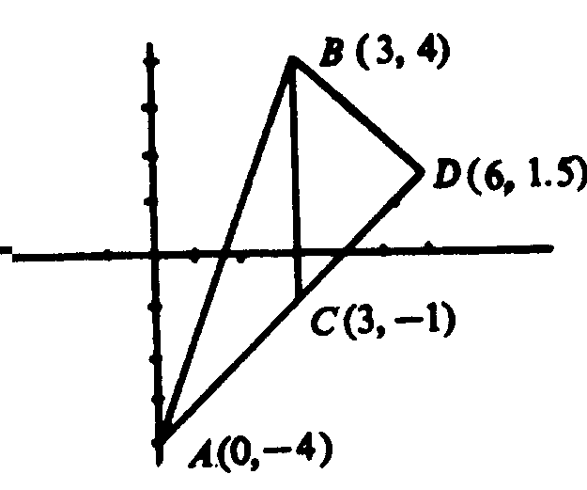  Figure 4
7. |  | If the right angles and sides are as marked in Figure 5, the area of trapezoid ABCD is 18, and a = 2b, then c =  a) 4.47  b) 8.94  c) 5.125  d) 2 |  |  | 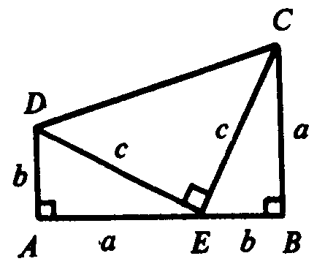  Figure 5
8. |  | If the given angles have the measures indicated in Figure 6, the measures of x and y are  - x = 100⁰, y = 90⁰  - x = 120⁰, y = 85⁰  - x = 120⁰, y = 90⁰  - x = 100⁰, y = 85⁰ |  |  | 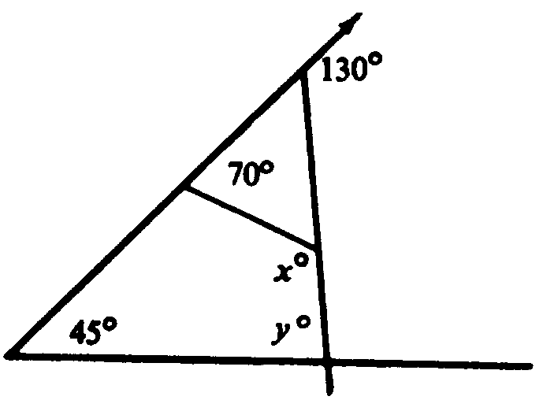  Figure 6
9. |  | If f(x) = −and x takes on successive values from −10 to −, then  a) f(x) increases throughout  b) f(x) decreases throughout  c) f(x) increases, then decreases  d) f(x) decreases, then increases
10. |  | A gold bar with dimensions $2^{'}×3^{'}×4^{'}$ has all of its faces rectangular. If it is melted and recast into three cubes of equal volumes, what is the length of an edge of each cube?  a) 1 b) 2 c) 3 d) 4
11. |  | The arithmetic mean of ten boys is 8 years, 6 months one of them is 13 years old. Then the arithmetic mean of remaining 9 boys is  - 9.5 b) 9 c) 8 d) 7
12. |  | A gold bar with dimensions $2^{'}×3^{'}×4^{'}$ has all of its faces rectangular. If it is melted and recast into three cubes of equal spheres, what is the radius of each sphere?  a) 1.24 b) 2.31 c) 2.92 d) 3.13
13. |  | A gold bar with dimensions $2^{'}×3^{'}×4^{'}$ has all of its faces rectangular. If it is melted and recast into three cubes of equal volumes, the surface area is increased (decreased by a factor of about  a) 2 b) 1.4 c) 3 d) 0.5
14. |  | If set A={2, 3, 4, 5}, Set B ={0, 1, 6, 7, 5}, then these sets are  a) Disjoint b) Supersets c) overlapping d) None
15.. |  |  | 2×3=3×2 represents  - Associative property w.r.t. multiplication  - Commutative property w.r.t. multiplication  - Multiplicative inverse  d) Distributive property of multiplication over addition
16. |  | If p, m and n are prime numbers, none of which is equal to the other two, what is the highest common factor of 24pm²n², 9pmn², and 36p(mn)³?  a) 3pmn b) 3p²m²n² c) 3pmn² d) 3pmn²n²
17. |  | If the perpendicular bisector of the segment with endpoints A(1, 2) and B (2, 4) contains the point (4 , c) then the value of c is  a) 7 b) c) − 7 d) 4
18. |  | If f(x) = and f = f(x), then x is  a) 1 only  b) −1 only  c) 1 or −1  e) Any real number
19. |  | The solution set of is  a) {3} b) {–3} c) -3<x<3 d) x<-3
20. |  | The notation N(x) means the numbers of prime numbers less than x. What is the value of N(N(30))?  a) 3 b) 4 c) 23 d) 29
21.. |  | If x = 3i, y = 2i and z = 1+i, then xyz² =  a) −12i b) 1−i c) 12−12i d) --6−6i
22. |  | A singer has memorized 12 different songs. If every time he performs he sings any three of these songs, how many different performances can he give?  a) 440 b) 12 c) 110 d) 220
23. |  | a) b) 3 c) d)
24. |  | The graph of cuts the x-axis at two points P and Q. The length of the line segment PQ is  (a) 6 (b) 18 (c) 8 (d) 2
25. |  | If a circle is tangent to both the x- and y-axis and has a radius of 1, then its equation is  (a) (x − 1)² + (y + 1)² = 1  (b) x² + y² = 1  (c) x² + (y+1)² = 1  (d) (x+1)² + y² = 1
26. | If two planes, P₁ and P₂ are parallel, then  - Any line in P₁ is parallel to any line in P₂  - AB =CD whenever points A and C are in P₁ and points B and D are in P₂  - Any line that intersects P₁ in exactly one point will intersect P₂ in exactly one point.  - Any line that intersects P₁ in more than one point must intersect P₂ in more than one point.
27. | If tan, then cos y =?  (a) 0 (b) 1 (c) −1 (d)
28. | (a) 88020 (b) 44000 (c) 24200 (d) 55150
29. | The number of solutions of the equation in the filed of complex numbers is  (a) 1 (b) 2 (c) 3 (d) infinitely many
30.. | The diagram shows 4 bricks enclosing a square. Each brick has length 16 and width 10. The length of the of the side of enclosed square is  (a) 6 (b) 8 (c) 36 (d) 10
31. | If sin x > 0 and cos x = − 0.8 , then tan x =  (a) 0.75 (b) −0.6 (c) -1.33 (d) − 0.75
32. | The volume of a rectangular box is 6480cm³, and the lengths of the sides are in the ratio 2:3:5. The length, in centimeter, of the shortest side of the box is  (a) 6 (b) 8 (c) 10 (d) 12
33. | If $2^{x}+3^{y}=\text{41}$, where x and y are natural numbers, then the value of x + y is  (a) 6 (b) 7 (c) 8 (d) 9
34.  B  x - 1  x + 1  A  C  D  x | The length of the sides of the acute angled triangle ABC are x-1, x and x+1. BD is perpendicular to AC. Then CD-DA equals  (a) $\frac{x}{8}$ (b) $\frac{x}{9}$ (c) 2 (d) 4
35.  90⁰  90⁰  H  A  B  C | In the figure is equal to  (a) (b) (c) (d)
36.  BB  C  A  D  G  O  E  F  . | A circle touches the sides of the square ABCD. BEFG is a square of side 1. The length of AB is  (a) 4 + 2√2 (b) (c) (d)
37. | (d) $2\text{log}x−\text{log}z$
38. | If one root of $x^{2}+\text{bx}+\text{18}$ is the twice the other, then b is  a) 9 b) 12 c) 6 d) none of these

39. If 0<x<1, then
${\text{lim}}_{n→∞}x^{n}=?$
- 1 b) 0 c) $∞$ d) none of these

40 A geometric series $\sum_{n=0}^{∞}{{\text{ax}}^{n}}$with $\left|x\right|<1$ converges to
a) 0 b) $\frac{a}{x+1}$ c) $\frac{a}{1−x}$ d) 1

41. The value of e^{ln n} is
  - n b) e c) 1 d) ln n
42. If 20 men can eat 200 kg of wheat in 40 days, then 10 men can eat 300 kg of wheat in how many days?
- 120 days b) 60 days c) 80 days d) none of these

43. In the expansion of (a + b)^{n}, the middle term when n is odd, is
a) (n/2+1)^{th} b) ((n+1)/2)^{th} and ((n+3)/2)^{th} c) (n+1/2)^{th} d) (n+3/2)^{th}

44. The domain of the function Sin⁻¹ x is
a) - $\frac{π}{2}$ x $\frac{π}{2}$ b) -1 <x <1 d) 0 x $π$ e) 0 < x <$π$
45.A vector V points from coordinates (5m, 3m) to coordinates (7m, 6m) in the x-y plane. The following displacement vector equivalent to V is
a), which points from (-6 m, -5 m) to (-4 m, -2 m) b) vector , which points from (-6 m, 1 m) to (-4 m, 4 m); c) vector , which points from (-8 m, -6 m) to (-10 m, -9 m), d) none of these
46) The magnitude of the difference between two vectors can never be greater than
- the magnitude of one of the vectors, b) the magnitudes of both vectors, c) the magnitude of their sum, d) their scalar product
47. If a· (b x a) is zero
- for all vectors a and b b) only when a = o or when b = 0 c) only when a and b are parallel to each other d) when a and b are perpendicular to one another

Mathematics- Descriptive Question(s)

    - Prove by mathematical induction that for all positive integral values of n, n(n² + 5) is divisible by 6.
    - Let ABC be an equilateral triangle and P be a point inside this triangle such that PA=$x$, PB=y, PC=z. If $z^{2}$=$x^{2}$+$y^{2}$, find the length of the sides of triangle ABC in terms of $x$and y.

Physics- Multiple Choice Questions

1. For the production of rainbow light is;
(a) reflected, (b) refracted, (c) both, (d) neither.

2. A hunter with a gun of maximum range 200 meters tries to shoot a leopard sitting in a tree. The tree is at a distance of 100 m from the hunter and the leopard is sitting at a height of 2 m from the ground. In order to be able to hit the leopard
(a) the hunter should aim his gun straight at the leopard.
(b) at an angle of 45⁰ from the horizon.
(c ) both of the above points will do.
(d) none of these point

3. At sea level ice melts at 0⁰ C. In order to keep it frozen at higher temperatures it is necessary to
(a) put it under enhanced pressure, (b) to put under reduced pressure,
(c) sprinkle salt on it, (d) none of these things will make any difference.

4. The louder the sound is, the greater is its,
(a) wavelength, (b) amplitude (c) none of these (d) both of these.

5. The period of oscillation of an oscillator depends on its mass m, with dimension of M, a restoring force constant k, with dimensions of ML²T⁻², and the amplitude A, with dimensions of L. Dimensional analysis shows that its period of oscillation should be proportional to

(a)A √m/k, (b) A²m/k, (c) A⁻¹ √m/k (d) A ²k ²/m

- If the length of a simple pendulum is reduced to halve and mass is double then period is:
(a) doubled (b)halved (c) remains unchanged
(d) decreased by a factor$\sqrt{2}$

- Sound waves can not be:
(a) reflected (b) refracted (c) diffracted (d) polarized

- The pressure exerted by a gas in an enclosed isolated container is :
(a) directly proportional to the density of the gas
(b) inversely proportional to the density of the gas
(c )independent of density of the gas
(d) directly proportional to the square of the density of the gas

- A particle that is moving along a straight line decelerates uniformly from 40 cm/s to 20 cm/s in 5.0 s and then has a constant acceleration of 20 cm/s² during the next 4.0 s. The average speed over the whole time interval is
(a) 57 cm/s (b) 140 cm/s (c) 86 cm/s (d) 43 cm/s

- If the initial speed of a projectile is doubled, its range will
(a) double (b) decrease by one-half (c) increases by a factor of four (d) decreases by a factor of four.

- A car going around a curve of radius R at a speed V experiences a centripetal acceleration A_{c}. What is its acceleration if it goes around a curve of radius 2R at a speed of 3V?
(a) (9 / 2) A_{c} (b) (4 / 3) A_{c} (c) (2 / 9) A_{c} (d) (2 / 3) A_{c}

- Which of the following is NOT a unit of force?
(a) Pound (b) Slug (c) Newton (d) kg.m/s²

- A women runs up the stairs. The gain in her gravitational potential energy is U. If she runs up the same stairs with twice the speed, what will be her gain in potential energy?
(a) U (b) 2U (c) U/2 (d) 4U

- Two balls are dropped from a height of 6 m. Ball A bounces back up to a height of 4m whereas ball B bounces back up to 2m. Which ball experiences the larger impulse during its collision with the floor?
(a) ball A (b) ball B (c) both experiences the same impulse. (d) its impossible to tell without knowing the masses of the balls.

- Two solid balls (one larger, the other small) and a cylinder roll down a hill. Which has the greatest speed at the bottom and which the least?
  - the larger ball has the greatest, the small ball has the least.
  - the small ball has the greatest, the larger ball has the least.
  - the cylinder has the greatest, the small ball has the least.
  - both balls have the same greater speed, the cylinder has the least.

- Which is larger for a disk of mass M and radius R that is rolling without slipping: its transnational or its rotational kinetic energy?
(a) its transnational kinetic energy. (c) both are the same.
(b) its rotational kinetic energy. (d) answer depends on the radius.

- A penny has a mass of 3.0 g, a diameter of 1.9 cm, and a thickness of 0.15 cm. What is the density of the metal of which it is made?
(a) 1.8 g / cm³ (b) 7.1 g / cm³ (c) 3.4 g / cm³ (d) 3.5 g / cm³

- A capillary tube is placed in a shallow dish of water. The water rises to a height h in the tube. How high will the water rise in the second tube with a radius one-third that of the first tube?
(a) h (b) h / 3 (c) 3h (d) 9h

- A horizontal pipe narrows from a diameter of 10 cm to 5cm. For a fluid flowing from the larger diameter to the smaller,
  - the velocity and pressure both increases.
  - the velocity increases and pressure decreases.
  - the velocity decreases and pressure increases.
  - the velocity and pressure both decreases.

- If the period of a simple harmonic oscillator is doubled, the amplitude will be
(a) unaffected (b) 7/10 as large (c) half as large (d) doubled

- A traveling wave passes a point of observation. At this point, the time between successive crests is
0.2 s.
(a) The wavelength is 5m (c) the wavelength is 0.2 m.
(b) The velocity of propagation is 5 m / s. (d) The frequency is 5 Hz.

- A positive charge that is free to move but is at rest in an electric field E experiences a force that is
- In the same direction as E. c) Perpendicular to E.
- In the direction opposite to E. d) Zero because the speed is zero.

- A motor running from a 220-V line is lifting a mass of 35 kg at a constant speed of 6.0 m/s. Assuming 100% efficiency, the current required is
(a) 0.27A (b) 9.4A (c) 7.7A (d) 3.34A

- The conservation of energy in an electric circuit is closely related to which of the following?
- Ohm’s law (c) Kirchoff’s junction rule
- Kirchoff’s loop rule. (d) Amperes law.

- Which of the following is not the phenomenon whereby polarized light can be produced from unpolarized light?
(a) Absorption (b) Reflection (c) Scattering (d) Diffraction.

- Two wires lie in the plane of paper and carry equal current in opposite direction as shown. At a point midway between the wires, the magnetic field is
  - zero.
  - into the page.
  - out of the page.
  - towards the bottom of the page.

- A force F has the components F_{x} and F_{y}. The magnitude F_{x} of the force component in the x direction is given by
(a) F- F_{y} (b) (F- F_{y})^{1/2} (c) (F)^{1/2}- (F_{y})^{1/2} (d) (F² - F_{y}² )^{1/2}

- The coefficient of static friction between car’s tires and a level road is 0.80. If the car is to be stopped in a maximum time of 3.0 s, its maximum speed is
(a) 2.4 m/s (b) 23.5 m/s (c) 7.8 m/s (d) 2.6 m/s
- A car towing a trailer is accelerating on a level road. The car exerts a force on the trailer whose magnitude is
  - the same as that of the force the trailer exerts on the car.
  - the same as that of the force the trailer exerts on the road.
  - the same as that of the force the road exerts on the trailer.
  - greater than that of the force the trailer exerts on the car.

- A ball is thrown vertically upward at 20 m/s. The ball comes to a momentary stop in approximately
(a) 0.5 s (b) 1.0s (c) 2.0 s (d) 1.5s

- The 2.5-kg head of an ax exerts a force of 80 kN as it penetrates 18 mm into the trunk of a tree. The velocity of the ax head when it strikes the tree is
(a) 1.2 m / s (b) 3.4 m / s (c) 34 m / s (d) 107 m / s

- During a serve, a tennis racket exerts an average force of 250N on a 60-g tennis ball, (initially at rest) for 5.0 ms. The ball’s kinetic energy afterward is
(a) 13J (b) 1.25J (c) 0.78J (d) none of all

- If we travel round the earth, we would find that the earth’s magnetic field
  - is the same in direction and magnitude everywhere.
  - varies in direction but not in magnitude.
  - varies in magnitude but not in direction.
  - varies in both direction and magnitude.

- When a moving charged particle enters a uniform magnetic field in a direction parallel to the field lines, the particle’s
(a) direction is changed. (c) energy is changed.
(b) velocity magnitude is changed. (d) motion is unaffected.

- A driver with a flashlight shines a light beam upward from the bottom of a pool at an angle of incidence of 40⁰. The light leaves the surface of the pool at an angle of refraction of 60⁰. The index of refraction of water is
(a) 0.67 (b) 0.74 (c) 1.3 (d) 1.5

- Molecular motion in a gas stops
  - at absolute zero. c) when the gas becomes solid
  - when the gas becomes liquid d) when the pressure on it exceeds a certain value
- The dimensional representation for Plank’s Constant is identical to that of
(a) torque (b) power (c) linear momentum
(d) angular momentum

- Imagine a system of units in which the unit of mass is 10 kg, length is 1km and time is 1 minute. Then 1J in this system is equal to
(a) 360 (b) 3.6 (c) 3.6 x 10⁶ (d) 3.6 x 10⁻⁴
- A particle moves along a straight line according to the Eq. s²= at²+2bt+c, where s is the distance traveled in time t and a, b, c are constants. Then, acceleration varies as
(a) s⁻³ (b) s^{3/2} (c) s^{-2/3} (d) s²

- A body moving with uniform acceleration has velocities 20 m s⁻¹ and 30 m s⁻¹ when passing through points A and B. Then the velocity mid-way between A and B is
(a) 25 m s⁻¹ (b) 25.5 m s⁻¹ (c) 24 m s⁻¹ (d) 10√6 m s⁻¹

- As the distance between the charges of an electric dipole increases,
(a) the dipole moment decreases. (c) the dipole moment remains the same
(b) the dipole moment increases (d) the total charges decreased.

- During a projectile motion, if maximum height equals the horizontal range, then the angle of projection with the horizontal is
(a) 45.0º (b) 63.4º (c) 71.5º (d) 76.0º

- A bomb of mass 9-kg explodes into two pieces of masses 3kg and 6 kg. The velocity of the mass 3-kg piece is 16-m s⁻¹. The kinetic energy of the mass 6 kg piece is
(a) 96 J (b) 192 J (c) 384 J (d) 768 J

- The momentum of a body decreases by 20%, then the percentage decrease in kinetic energy is
(a) 40% (b) 20% (c) 36% (d) 44%

- A spring of force constant K is cut into three equal parts. Than the force constant of each part is
(a) K (b) 3K (c) K/3 (d) √3 K

- A monkey of mass 20-kg rides on a 40-kg trolley moving with constant speed of 8 ms⁻¹ along a horizontal track. Frictional forces can be neglected. If the monkey jumps vertically with respect to the moving trolley to grab the overhanging branch of a tree, the speed of the trolley after the monkey has jumped off is
(a) 0 ms⁻¹ (b) 8 ms⁻¹ (c) 12 ms⁻¹ (d) 16 ms⁻¹

- The mass and diameter of a planet are twice those of the earth. What will be the period of oscillation of a pendulum on this planet, if it is a second’s pendulum on the earth?
(a) √2 sec (b) (1/√2) sec (c) 2 sec (d) 2 √2 sec
- Two particles A and B initially at rest, move towards each other under a mutual force of attraction. At the instant when the speed of A is V and speed of B is 2V, the speed of the center of mass of the system is
(a) 0 (b) V (c) 1.5V (d) 3V

- A body is executing S.H.M. What fraction of the total energy of the body will be kinetic when its displacement from the mean position is half of its amplitude?
(a) 1/2 (b) 3/2 (c) 3/4 (d) 1/4

- The pressure of the gas is increased by 1%. The percentage decrease in volume of the gas, under isothermal conditions, is
(a) 99 (b) 1/99 (c) 100/101 (d) 99/101

Physics- Descriptive Question(s)

A frog is riding on the top of a cylindrical piece of wood floating in still water.
Half of the wood, with a diameter of 4 cm and length 20 cm, is immersed in water.
The density of water is 1 gm/cc.
- What is the mass of the wood along with the frog?
- After the frog slowly goes into the water only one third of the wood remains immersed in water. Calculate the mass of the frog.
- Calculate x, the distance between the water level and the center of the circular end of the wooden piece.
- Briefly describe the motion of the wood after the instance the frog moves into the water. Give a rough sketch of x as a function of time.

END

